1. **INTRODUCTION** 
   * Overview

CRM APPLICATION THAT HELPS TO BOOL A VISA SLOT

* + 1. visa slot management project is a system that is used to track and manage the availability of visa slots, which are appointments that are required for certain visa applications. It might be used by a government agency or a visa processing center to schedule and manage appointments with applicants.

* + Purpose
    1. visa slot management project is a system that is used to track and manage the availability of visa slots, which are appointments that are required for certain visa applications.

1. **Problem Definition & Design Thinking**  Empathy Map

Paste the empathy map screenshot

Ideation & Brainstorming Map

Paste the Ideation & brainstorming map screenshot.

1. **RESULT**

Data Model:

|  |  |
| --- | --- |
| **Object name** | **Fields in the Object** |
| obj1-Passport | |  |  | | --- | --- | | Field label | Data type | | Contact Number | Number | | Contact Number | Number | |
| obj2-Visa | |  |  | | --- | --- | | Field label | Data type | | Passport Number | Master Relationship | | Passport Number | Master Relationship | |

**Activity & Screenshot**

Attach the screenshots of your project activity along with the description.

Report

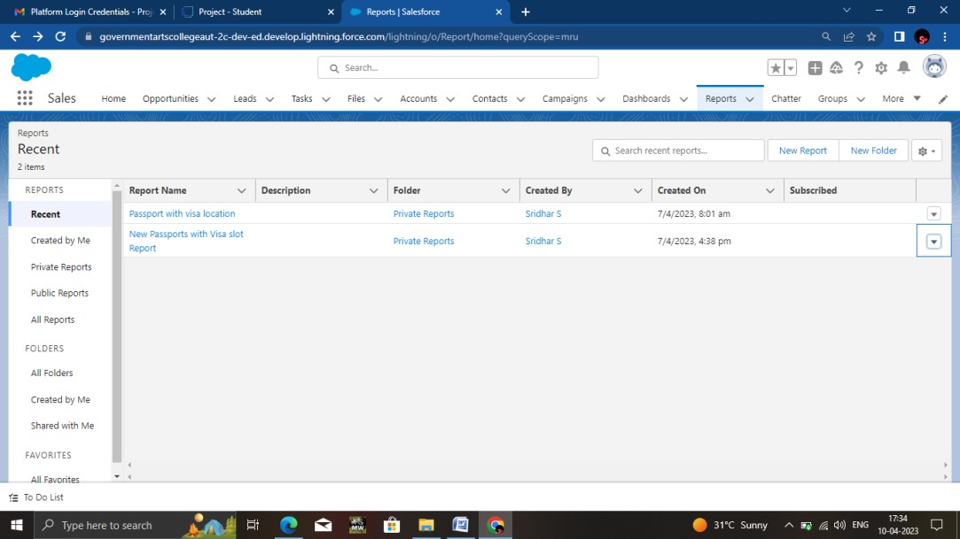

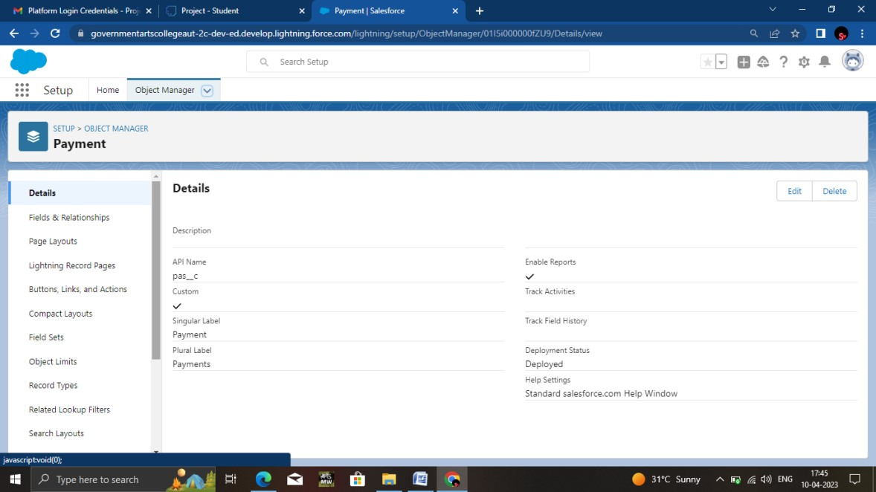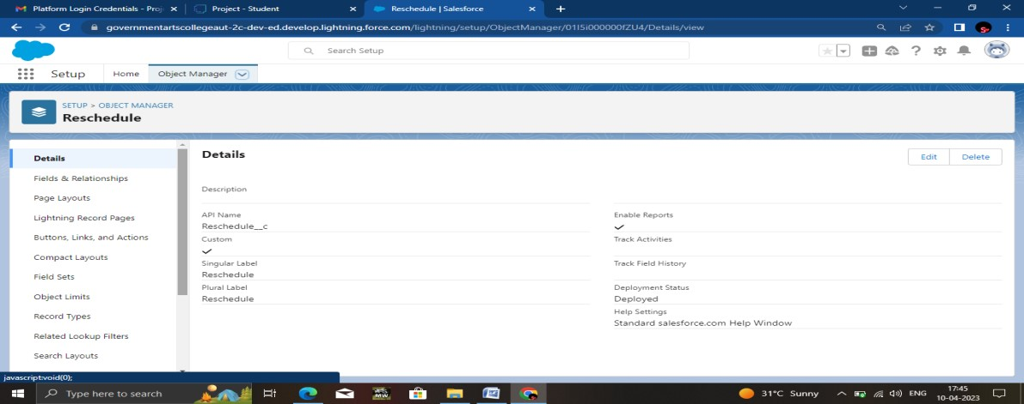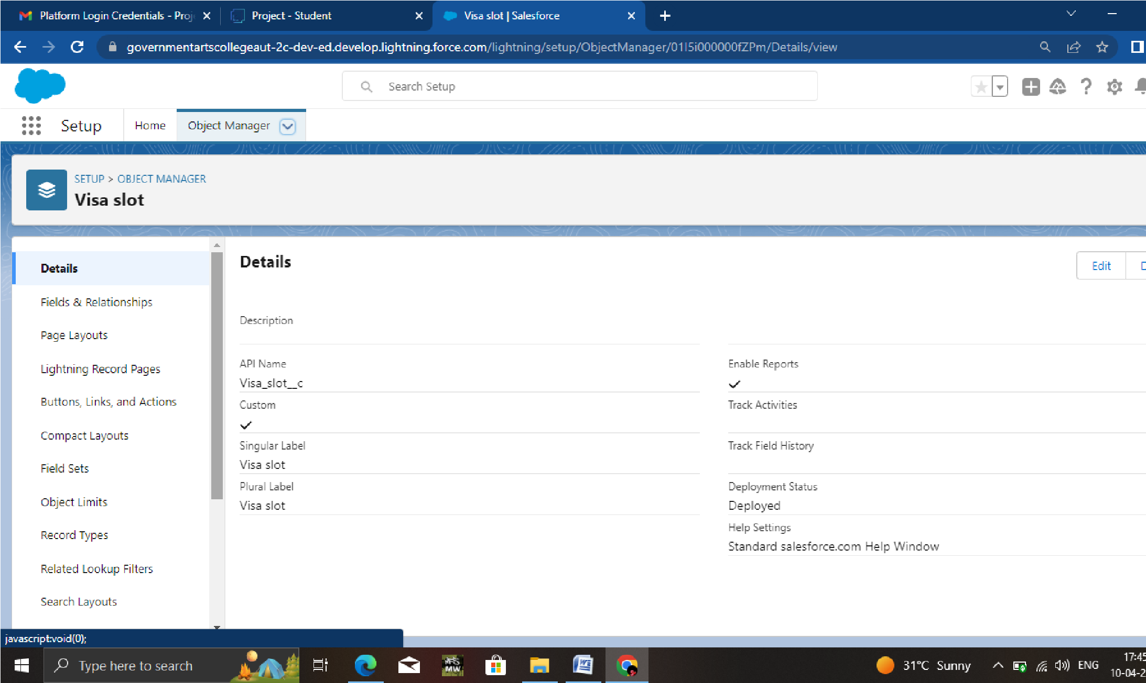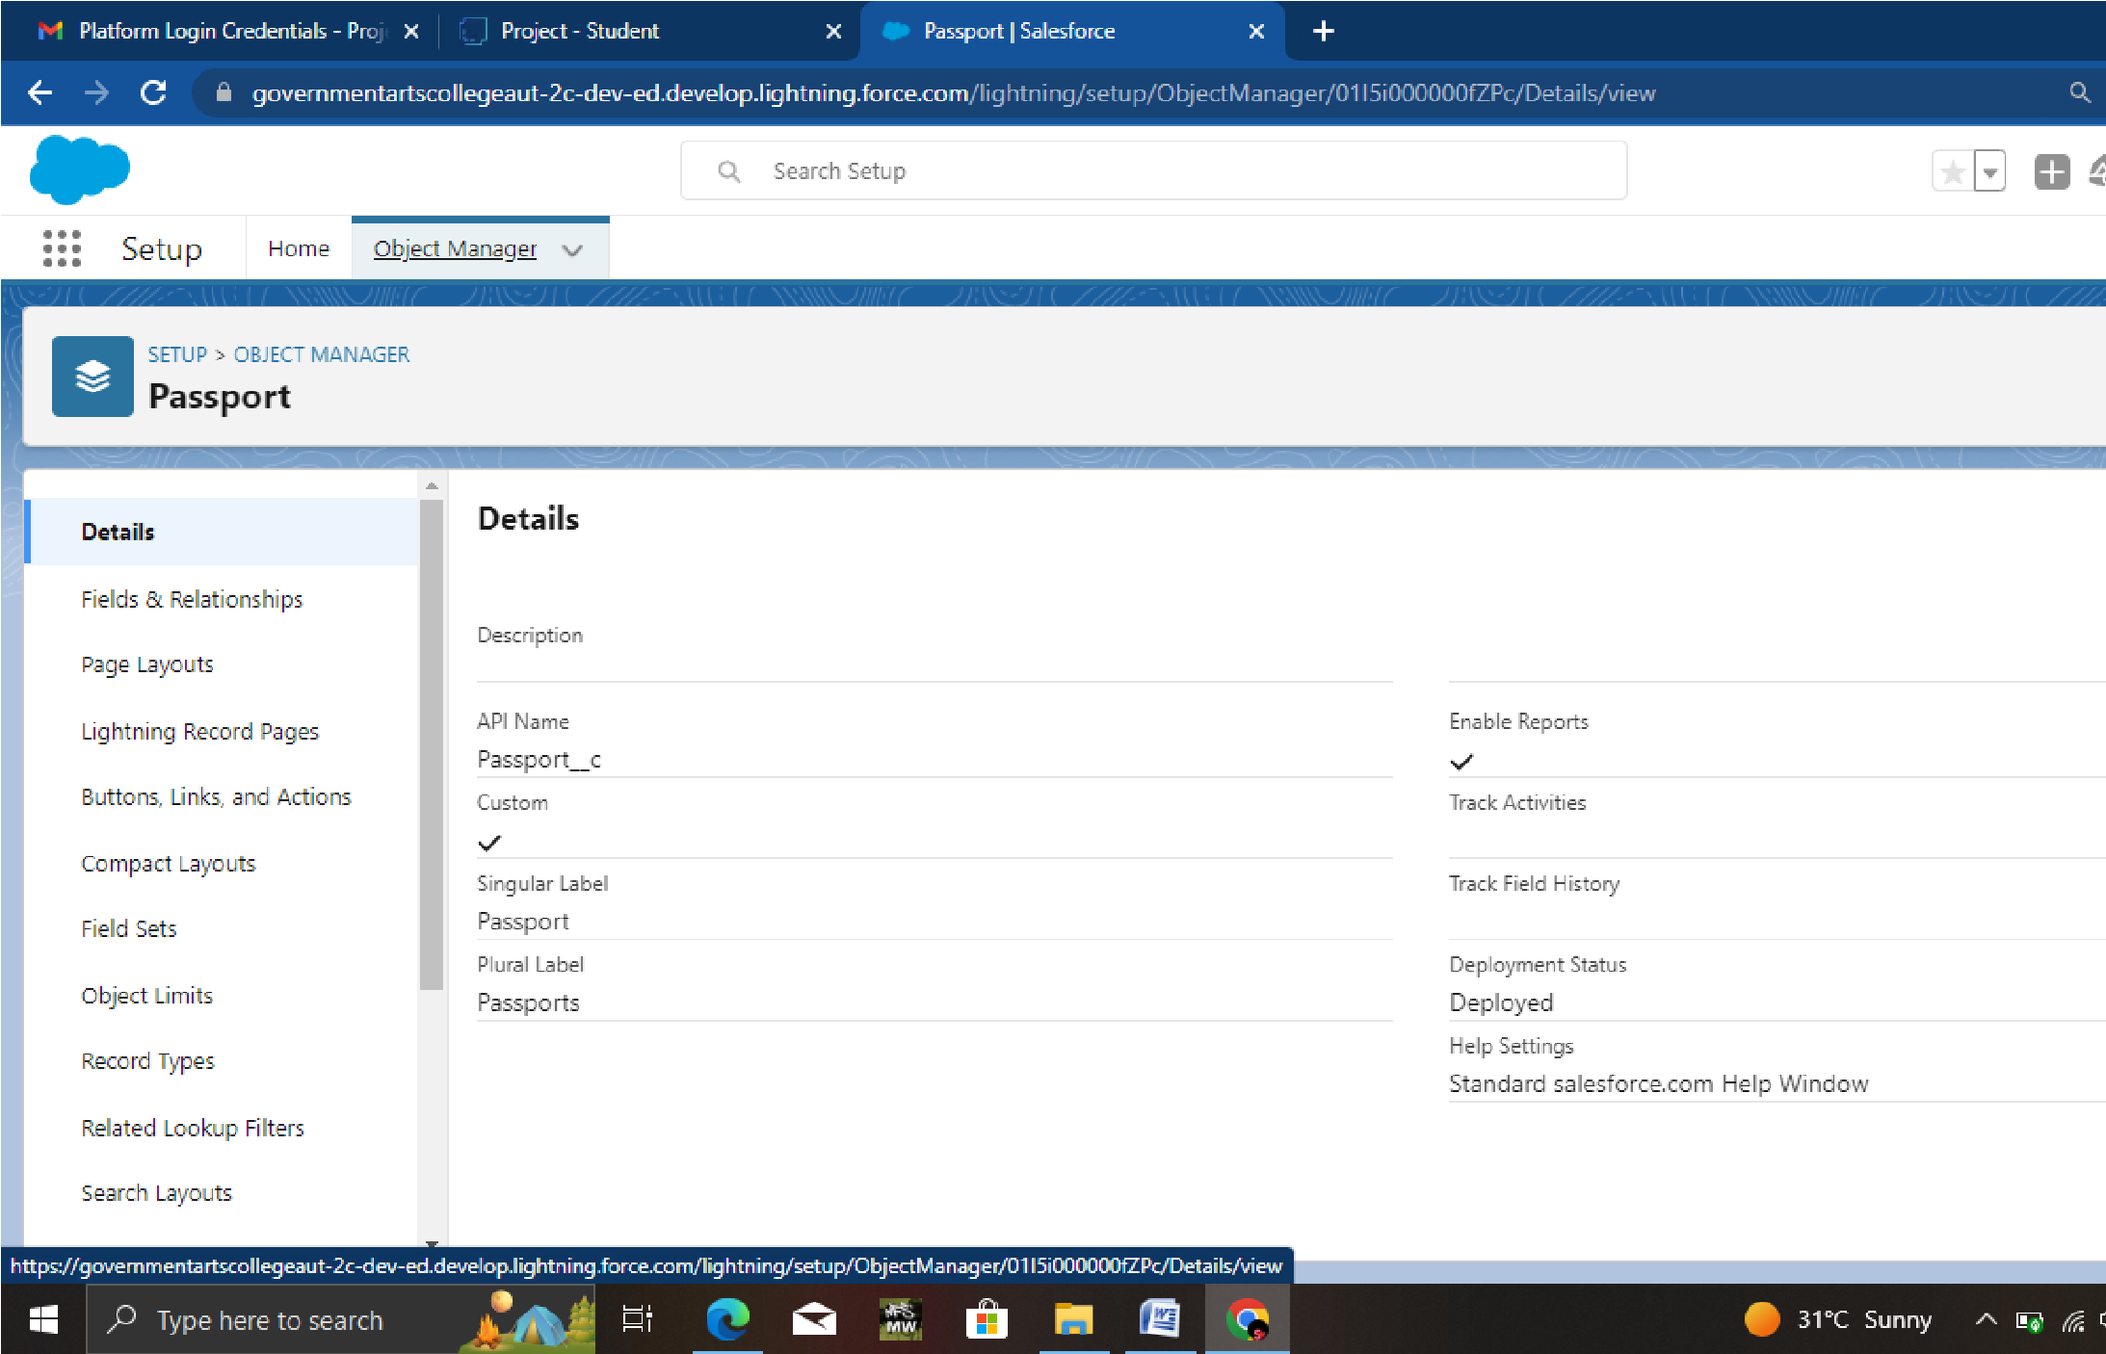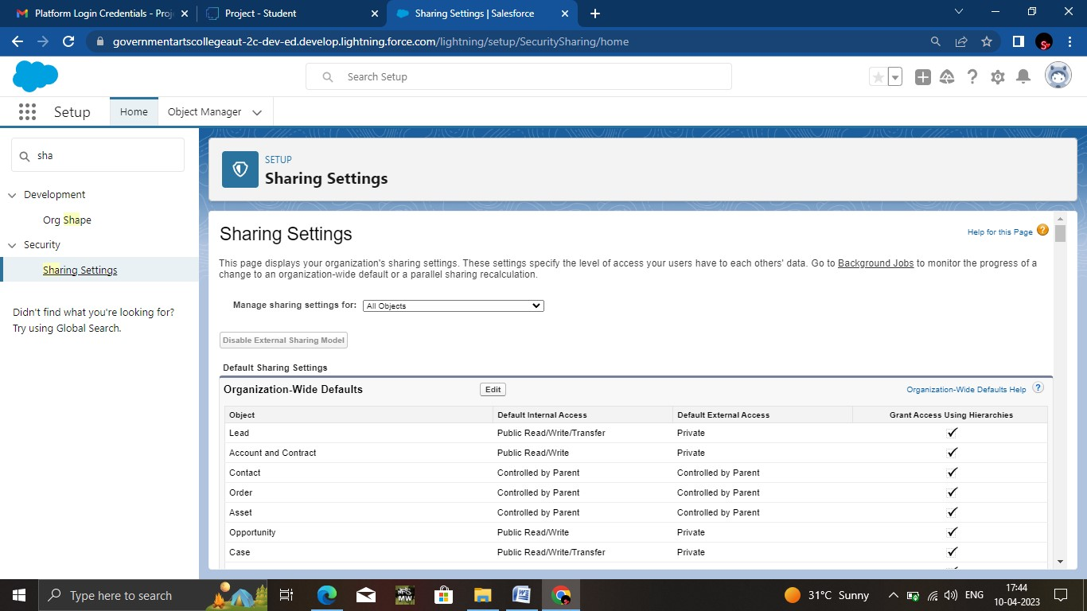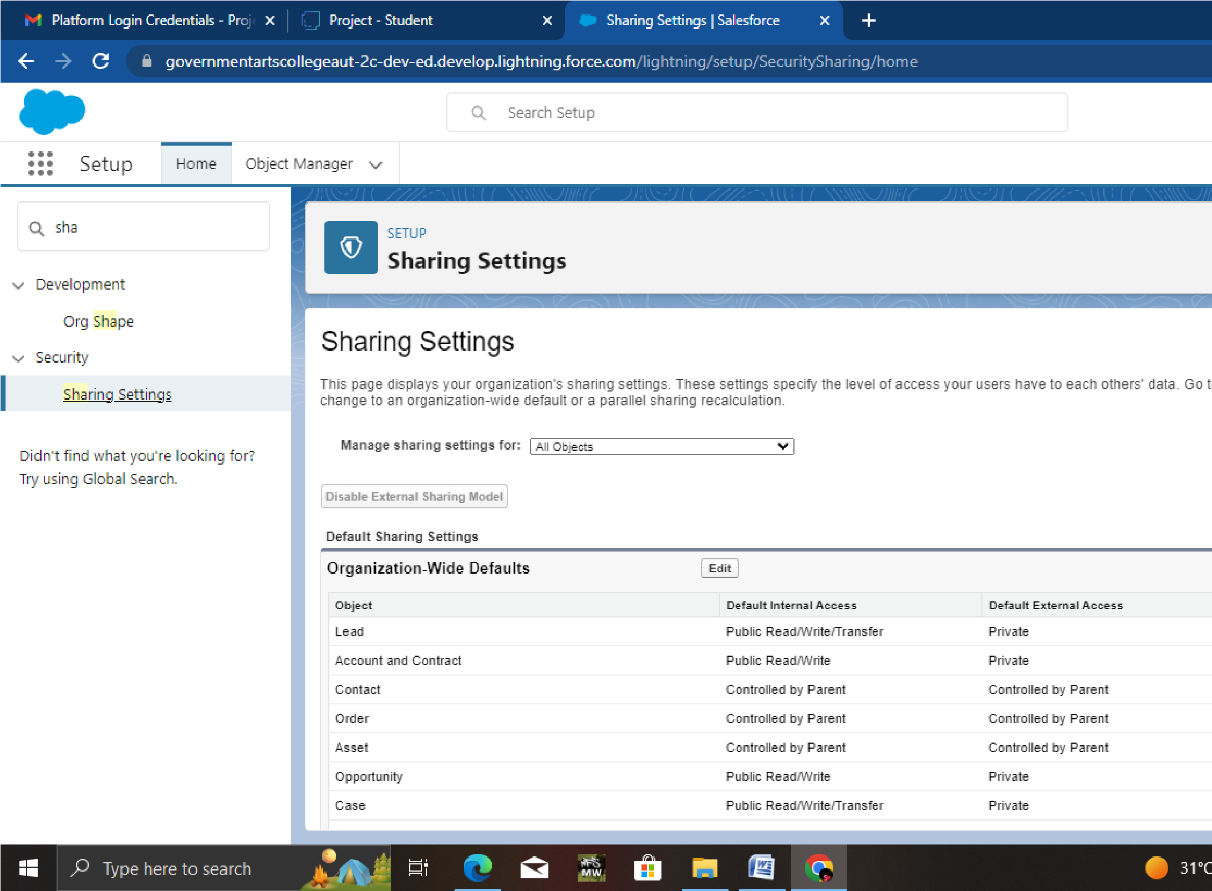

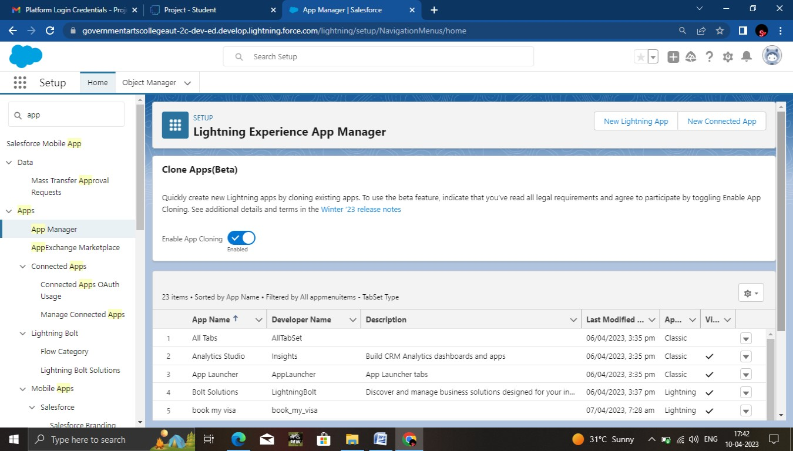

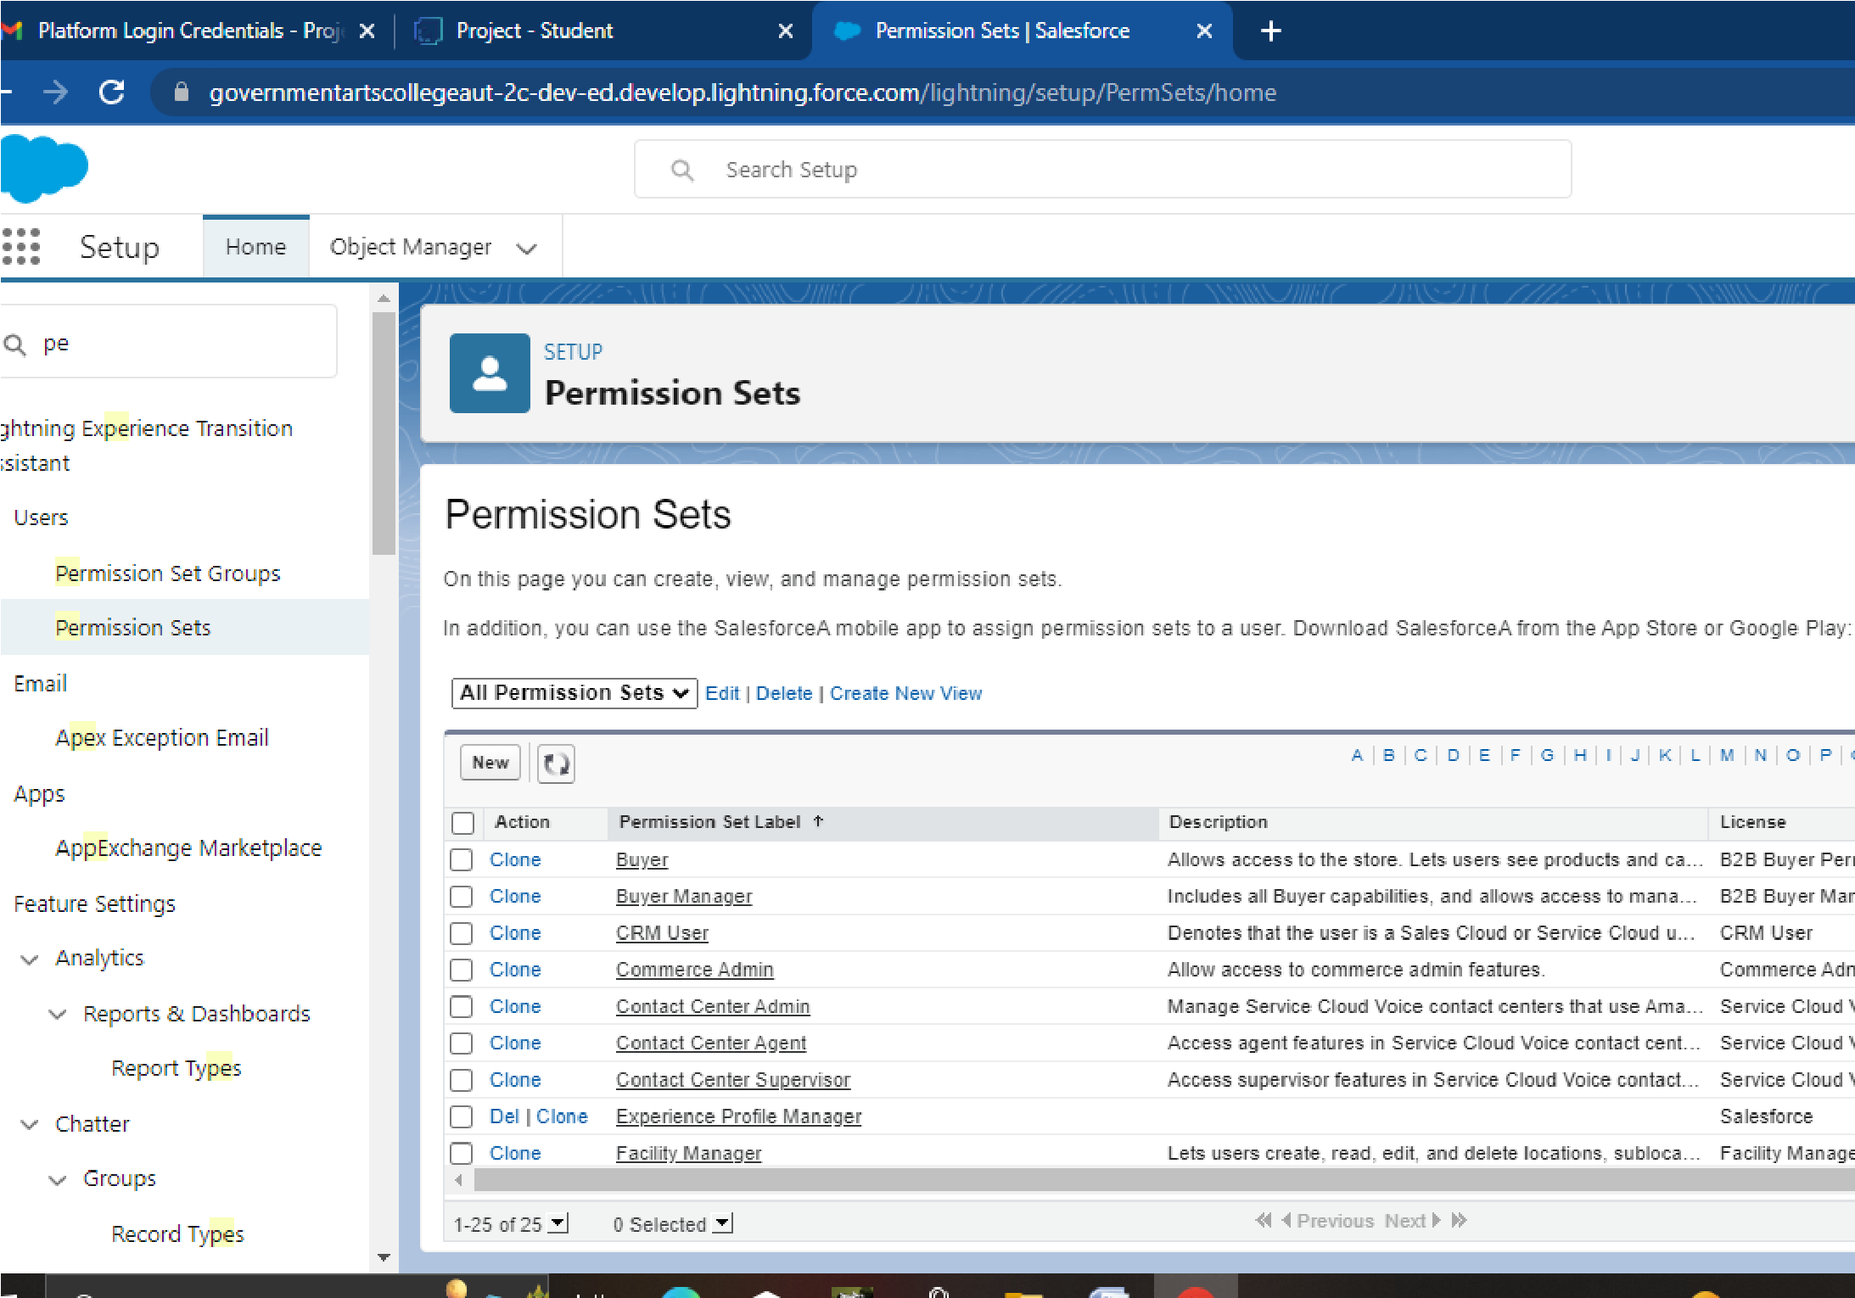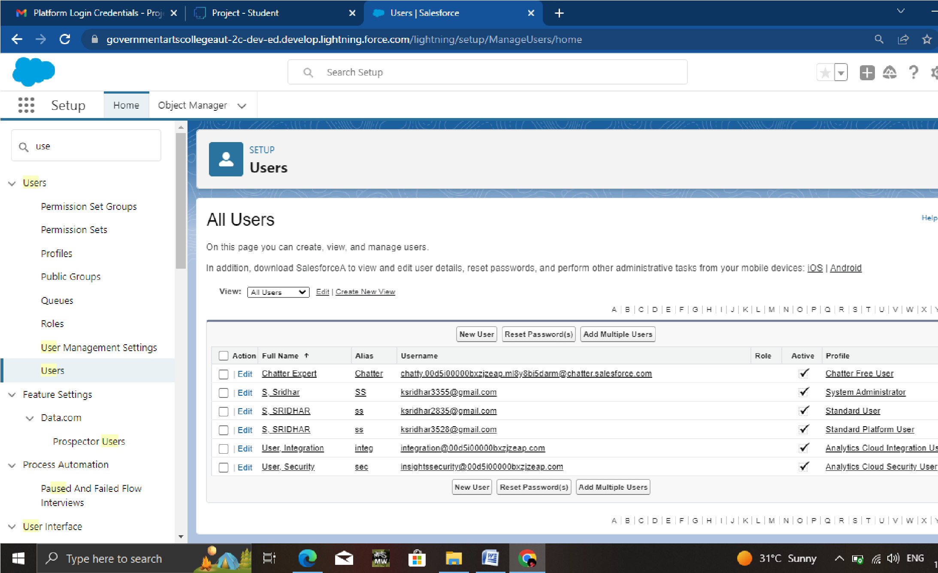

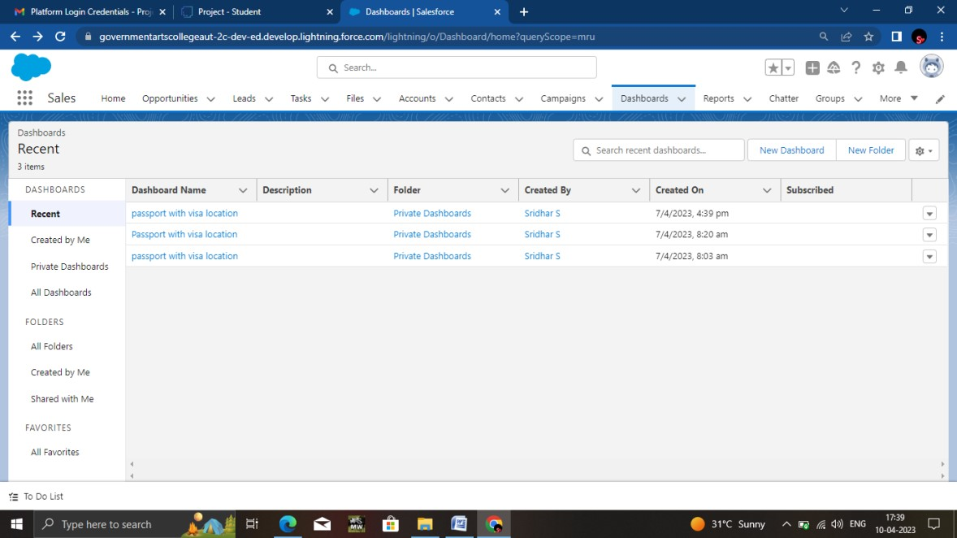

1. **Trailhead Profile Public URL**

**Team Lead -****https://trailblazer.me/id/mwaranm1**

**Team Member 1 - https://trailblazer.me/id/mperumal21**

**Team Member 2 –https://trailblazer.me/id/mwaranm1**

**Team Member 3 – https://trailblazer.me/id/snaveen65 ADVANTAGES & DISADVANTAGE ADVANTAGES**

* + - * **Beneficial for different department or teams of the business.**
      * **Improve customer service.**
      * **CRM made targeting and marketing simple.**
      * **Visa slot management are appointments that are certain visa application.**

**DISADVANTAGE**

* + - * **Technical support**
      * **Security Issues**
      * **Staff Resistance.**

* 1. **APPLICATION**

**Customer Relationship Management (CRM) is a set of**

**Integrated, data driven software solutions that helps manage track and store information related to your company’s current and potential customers.**

* 1. **CONCLUSION**

**We worked well on this project.**

Customer relationship management is a technology

For managing all your company’s relationship and customers.

* 1. **FUTURE SCOPE**

In future our project gets more importace because storing of

Informations is very essential. I so we think our project makes an impact in future.

Project Report Template